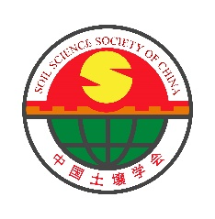
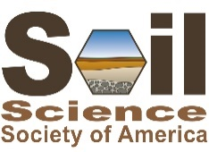
SSSA-SSSC Joint Webinar on Soils and Climate Change

Cross-cultural and international scientific cooperation is essential as we face global issues of climate change, food security, and environmental restoration. We have much to learn from scientists around the world, and our efforts will be strengthened and more effective when soil scientists are working together. To promote such collaboration and communication in soil science, the Joint Working Group of Soil Science Society of America and Soil Science Society of China is pleased to announce the first scientific meeting jointly sponsored by the two societies.
All are invited to attend the webinar!

Please click the below link to register and attend the conference for free.
Webinar link (registration is required):
https://www.soils.org/education/SSSA-SSSC-Joint-Webinar/

Date (U.S. Central Time): February 22, 2023, at 18:30-20:40 PM
Date (China Time): February 23 at 8:30-10:40 AM

Organizing committee:
James M. Tiedje, Xiaoyuan Yan, Sabine Grunwald, Michael Thompson, Jianwen Zou

Contacts:
Marie Johnston (mjohnston@sciencesocieties.org)
Fang Wang (wangfang@issas.ac.cn)

Opening ceremony
Time slot |  | Speaker | Topic | Moderator
China  (23 Feb) | Central USA  (22 Feb)
8:30-8:32 | 18:30-18:32 | Marie Johnston  Education Project Manager and Content Creator of SSSA | Technical instruction | Host
8:32-8:35 | 18:32-18:35 | Michael Thompson  President (elect) of SSSA  Iowa State University | Welcome speech | Fang Wang  Chair of International Collaboration Working Committee of SSSC  Institute of Soil Science, CAS
8:35-8:38 | 18:35-18:38 | Xiaoyuan Yan  Vice president and secretary general of SSSC  Institute of Soil Science, CAS | Welcome speech
8:38-8:40 | 18:38-18:40 | Group photo (screen shot)
Presentations (20 min+ 5 min）
8:40-9:05 | 18:40-19:05 | Rattan Lal  Ohio State University | Managing soils for adaptation and mitigation of anthropogenic climate change | Jianwen Zou  Nanjing Agricultural University  Robert Horton  Iowa State University
9:05-9:30 | 19:05-19:30 | Xiaojuan Feng  Institute of Botany, CAS | Molecular alterations of soil organic matter in alpine grasslands under warming
9:30-9:55 | 19:30-9:55 | Sabine Grunwald  University of Florida | Global assessment of soil carbon
9:55-10:20 | 19:55-20:20 | Tida Ge  Ningbo University | Characteristics of paddy soil: specifics in dynamics in organic carbon cycling
10:20-10:25 | 20:20-20:25 | James M. Tiedje  Michigan State University | Summary
10:25-10:26 | 20:25-20:26 | Marie Johnston  Education Project Manager and Content Creator of SSSA | Closing instruction
Conference Program

Brief introduction of Moderators and Speakers
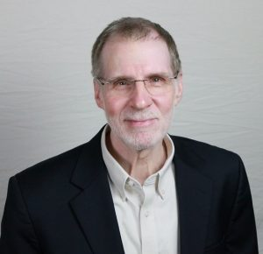
Dr. Michael Thompson is the Soil Science Society of America President-elect beginning a three-year succession, He is a professor at Iowa State University where he teaches courses in soil, plant, and environmental chemistry at the undergraduate and graduate levels. His research program centers on environmental applications of soil chemistry and mineralogy. These studies seek to identify chemical and physical conditions that favor stability, transformations, and movement of nutrients, soil organic matter, and the anthropocentric contaminants in soils.

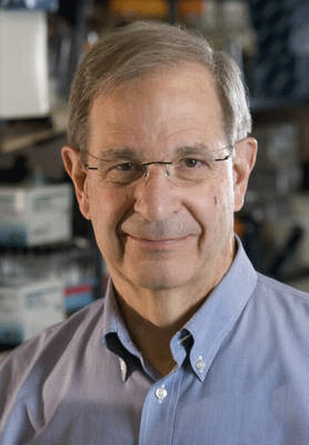
Dr. James Tiedje is a University Distinguished Professor, a Foreign Member of the Chinese Academy of Sciences, the Fellow of the American Association for the Advancement of Science, the American Academy of Microbiology, the Soil Science Society of America, and Soil Science Society of China, and is a member of the U.S. National Academy of Sciences. Dr. Tiedje devoted his life to studying microbial ecology, physiology and diversity, especially regarding the nitrogen cycle, biodegradation of environmental pollutants and use of molecular methods to understand microbial community structure and function, and is a leading expert in the fields of microbial ecology and antimicrobial resistance. He is the former Editor-in-Chief of Applied and Environmental Microbiology, Molecular Biology Reviews and mBio. He has published over 700 papers in international journals, and these publications have attracted over 136,000 citations with an H-index of 176. He was awarded the 1992 Finley Prize from UNESCO for research contributions in microbiology of international significance, the President of the American Society for Microbiology and the International Society for Microbial Ecology and awarded the 2023 ASM Lifetime Achievement Award.

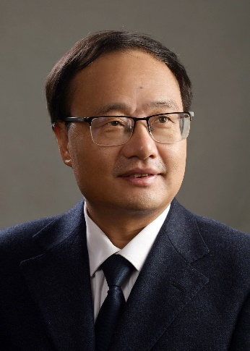
Dr. Xiaoyuan Yan is a professor in the Institute of Soil Science, Chinese Academy of Soil Sciences. He is also the vice president and secretary general of the Soil Science Society of China (SSSC) and the director of nitrogen working group of the SSSC. His research interests include nutrients (particularly carbon and nitrogen) cycles in terrestrial ecosystems and their responses to climate change drivers including elevated CO₂ concentrations and warming, mitigation of greenhouse gas and non-point source pollution at various scales. He has published more than 200 papers in peer-reviewed journals, including Nature, Nature Geoscience, Nature Food, PNAS, Global Change Biology, and Environmental Science & Technology, with >12000 citations and h index of 52. He was awarded for “Research Fund of Outstanding Young Scientists” supported by the Natural Science Foundation of China.

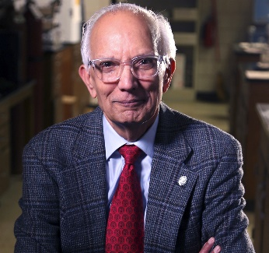
Dr. Rattan Lal is a Distinguished Professor of Soil Science at the School of Environment and Natural Resources at the Ohio State University. He is a former President of the Soil Science Society of America and the International Union of Soil Sciences, a laureate of the World Food Prize, and serves as Adjunct o Visiting Professor at institutions in Iceland, India, and Chile. His signature research areas include soil carbon sequestration and climate change, soil health and restoration, tropical systems, and conservation agriculture. He received a B.S. from Punjab Agricultural University, a M.S. from Indian Agricultural Research Institute, and a Ph.D. from Ohio State University.
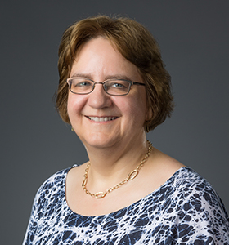
Dr. Sabine Grunwald is Professor of Pedometrics, Landscape Analysis & GIS at the Soil, Water and Ecosystem Sciences Department, University of Florida, Gainesville, Florida, USA. She is a SSSA Fellow and internationally recognized for research in pedometrics, carbon science, and soil health. Her research has focused on digital modeling of soil and terrestrial carbon from field to global scale, modeling of soil-ecosystem functions (pedo-econometrics), soil proximal sensing, remote sensing, geoscience, and AI (machine and deep learning) applied to soil health. She earned a M.Sc. in Environmental Science and Development of Rural Areas and a Ph.D. in Environmental Science from the Justus Liebig University in Giessen, Germany and a Ph.D. in Integral and Transpersonal Psychology. She is Chief Editor of Frontiers in Soil Science, Pedometrics Journal, Associate Editor of Sensors J. and had served as Associate Editor of the SSSA J. Dr. Grunwald ranked in the top 2% of World Scientists in 2022 (Stanford University Global Ranking List).
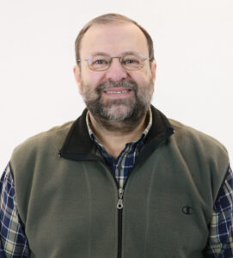
Dr. Robert Horton is a Professor in the Agronomy Department at Iowa State University. His program addresses soil physical processes and soil physical properties, with a focus on coupled heat and mass transfer in soil. His singular contributions include a comprehensive theory of coupled heat, water and chemical transfer in soil, quantifying in situ unsaturated soil hydraulic conductivity and dynamic subsurface water evaporation, and devising and validating a method to control fertilizer nitrogen leaching.

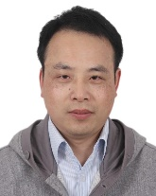
Dr. Jianwen Zou is a professor in the College of Resources & Environmental Sciences at Nanjing Agricultural University. Currently, he is the vice president of Soil Science Society of China and the Director of Key Laboratory of Green and Low-carbon Agriculture in Southeastern China, Ministry of Agriculture and Rural Affairs, China. He got two Ph.Ds, one in Soil Science at Nanjing Agricultural University in 2005 and the second one in Ecology at Rice University in 2007. His doctoral thesis was awarded as “National Excellent Doctoral Thesis in China” by the Ministry of Education, China in 2007. His research focuses on agriculture and global change, such as soil greenhouse gases mitigation, response and adaptation of cropland to climate change. He has more than 100 peer-reviewed articles published in decent journals in Chinese and English, such as Ecology Letters, Global Change Biology, Global Biogeochemical Cycles. He was awarded for “Research Fund of Outstanding Young Scientists” supported by the Natural Science Foundation of China in 2012.
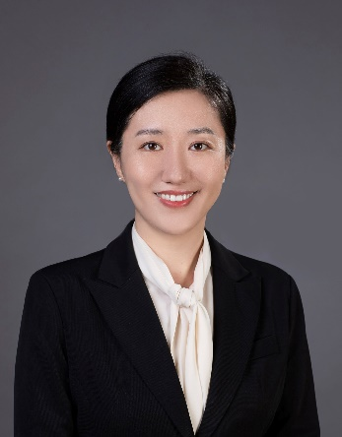
Dr. Xiaojuan Feng is a Professor at the Institute of Botany, Chinese Academy of Sciences. Her research focuses on the biogeochemical processes regulating the stabilization, transformation, and transport of soil organic carbon under global changes. She is specialized at using biomarkers and compound-specific ¹³C and ¹⁴C analyses to examine organic matter sourcing and processing in soils and fluvial systems. Xiaojuan did postdoctoral work at ETH Zurich and Woods Hole Oceanographic Institution and is currently Subject Editor for Global Change Biology and Associate Editor for the Journal of Geophysical Research: Biogeosciences and GCA (Geochimica et Cosmochimica Acta). Xiaojuan has a B.S. in environmental sciences, a M.S. in geography/environmental studies, and a Ph.D. in geography. She was awarded for “Research Fund of Outstanding Young Scientists” supported by the Natural Science Foundation of China.
Dr. Fang Wang is a Professor at the Institute of Soil Science, Chinese Academy of Sciences, and University of Chinese Academy of Sciences. Her research focuses on soil pollution and remediation, especially for organic chemicals and emerging contaminants. She is the author of more than 190 peer-reviewed journal articles in The Innovation, Environ Sci Technol, Water Research and Soil Biol Biochem, etc. She has been awarded the Alexander von Humboldt Fellow for Experienced Researcher from Germany; Shennong Young Talent from the Ministry of Agriculture and Rural Affairs of China; Distinguished Young Scholar from the Natural Science Foundation of Jiangsu, China; and a Young Talent of Lu Jia-Xi Award from Chinese Academy of Sciences. She serves as Co-Editor-in-Chief of Environmental Technology & Innovation, Associate Editor of Science of the Total Environment, Academic Editor of The Innovation and Editor of Sustainable Horizons. She is the Chair of International Collaboration Committee of Soil Science Society of China (SSSC), Co-Chair of working group of Collaboration between SSSC and Soil Science Society of America.

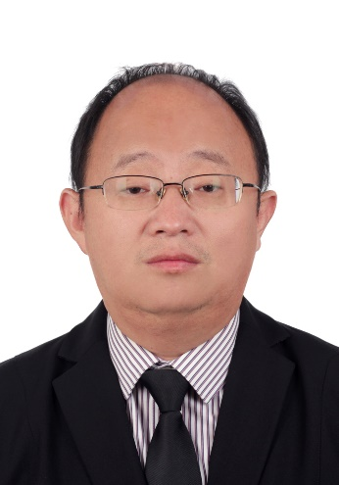
Dr. Tida Ge is a Professor of Environmental Soil Science and Biogeochemistry at Ningbo University with expertise in soil ecology, biogeochemistry, land use, agroecology, and especially nutrient cycling. His research focuses on rhizosphere ecology in agricultural systems and the use of isotopes, sequencing technologies, and biomarkers to evaluate soil functioning. He was awarded “Research Fund of Excellent Young Scientists” from the Natural Science Foundation of China, Newton Advanced Fellowship from The Royal Society of UK, the Alexander von Humboldt Fellow for Experienced Researcher from Germany and a Young Talent of Lu Jia-Xi Award from Chinese Academy of Sciences. He is an active member of several editorial boards. He is Associate Editor for both Soil Science Society of America Journal and Frontiers in Agronomy, and he’s Editor for Soil Ecology Letters, Biology and Fertility of Soils, and Plant and Soil. He has a Ph.D. in horticultural science from Shanghai Jiaotong University.

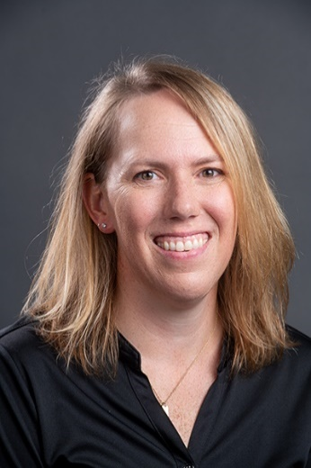
Dr. Marie Johnston is the Education Project Manager and Content Creator at the Soil Science Society of America, where she manages the North American Proficiency Testing program and develops professional training in soils and agronomy. Prior to this role, Marie served as Assistant Editor for the Soil Science Society of America Journal, Crop Science, and the Journal of Environmental Quality. Her experience includes private consulting as an Environmental Scientist at Wood and research in forest ecology, soil physics, and ecohydrology at the University of Wisconsin-Madison Arboretum. Marie has a B.S. in Water Resources and B.S. in Mathematics from the University of Wisconsin-Stevens Point, and a M.S. in Soil Science and Ph.D. in Soil Science from the University of Wisconsin-Madison.

